**USER MANUAL**

FOR

**MOBILE CLONING AND ITS DETECTION**©

**Guide:** **Submitted By:**

Mr. Arun Kumar Akash Sinha (03796502710)

Assistant Professor Alok (04796502710)

Deptt Of Computer Science Ajay Dagar (05096502710)

Harshit Trivedi (06496502710)

**SYSTEM REQUIREMENTS**

**Minimum Hardware Requirement:**

* **Processor** : 2.6 GHz Intel Pentium IV or Equivalent
* **Memory**  : 512 MB RAM (Recommended 2GB RAM)
* **Disk Space** : 1 GB of free disk space
* 15 inches Color Monitor
* 104 Keys Keyboard

**Minimum Software Requirement:**

**Operating System:** Windows 2000/XP or above

* MySQL Server 5.0 (or above)
* SQLyog 10 (or above)
* JDK
* NetBeans IDE 6.9 (or above)

**HOW TO RUN THE APPLICATION**

Follow these steps to run the application:

1. Open NetBeans IDE.
2. Click on **“File”**, and select **“Open Project…”**

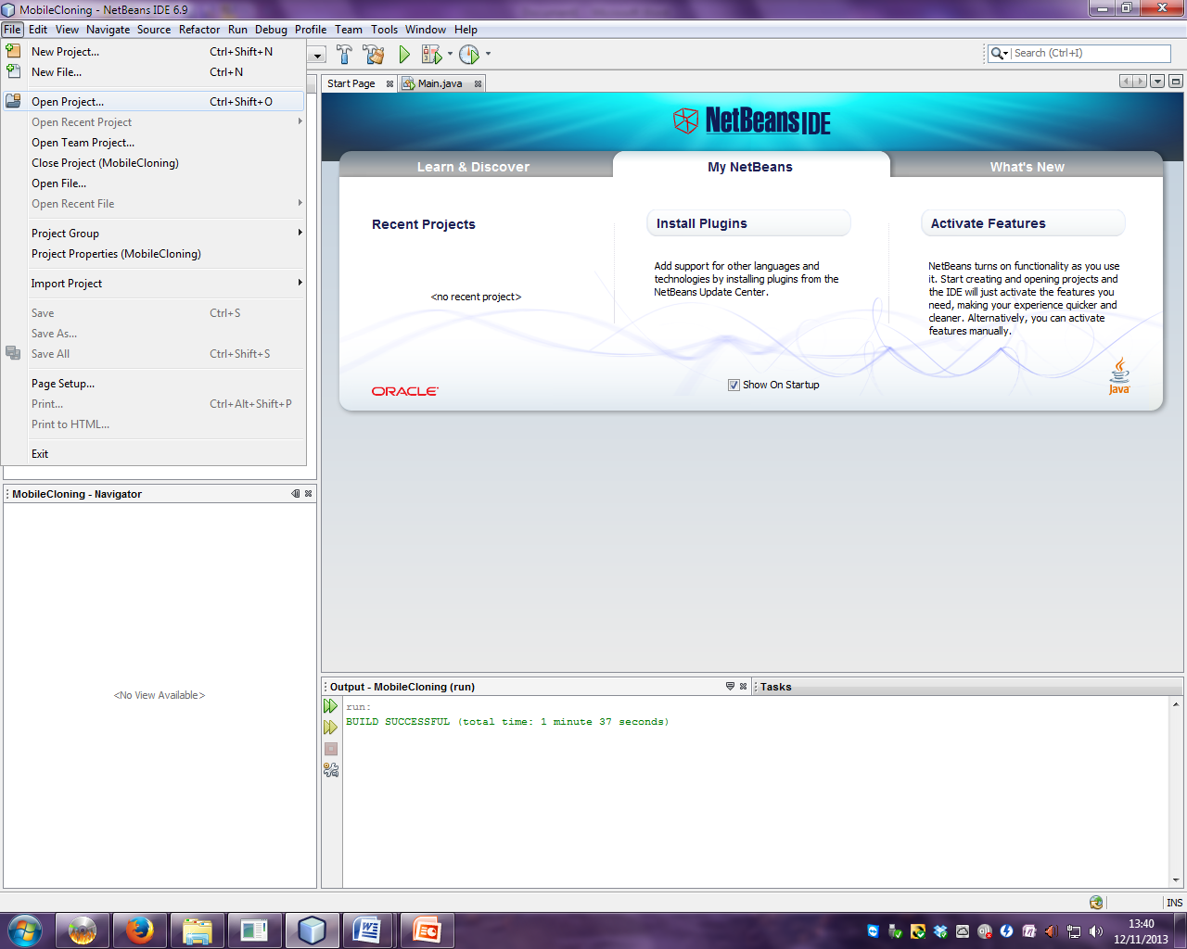

1. Navigate to the java project entitled **“MobileCloning”**.

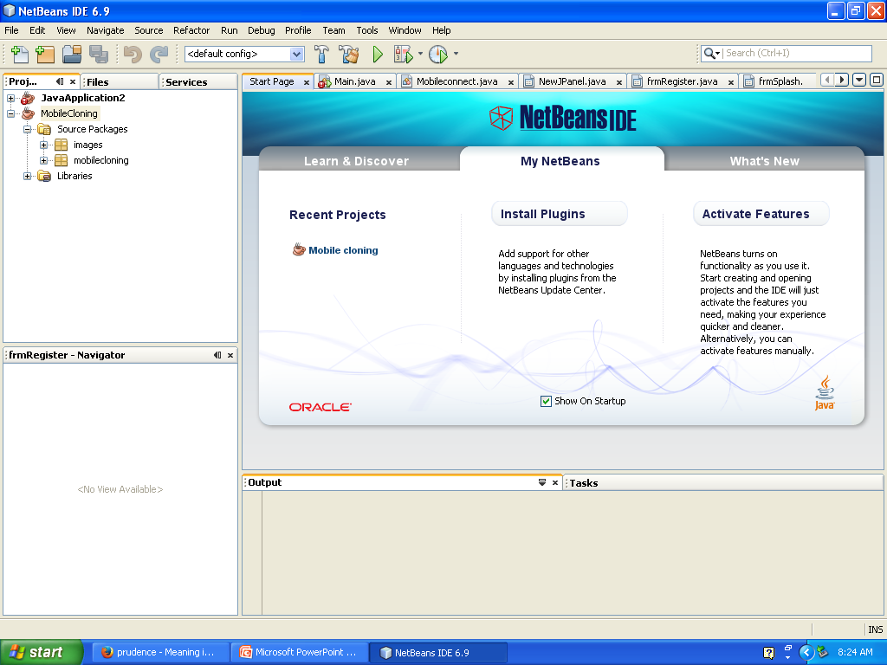

1. Now, to run the project, right click on the project name “MobileCloning” in the Projects window and click on “Run”.

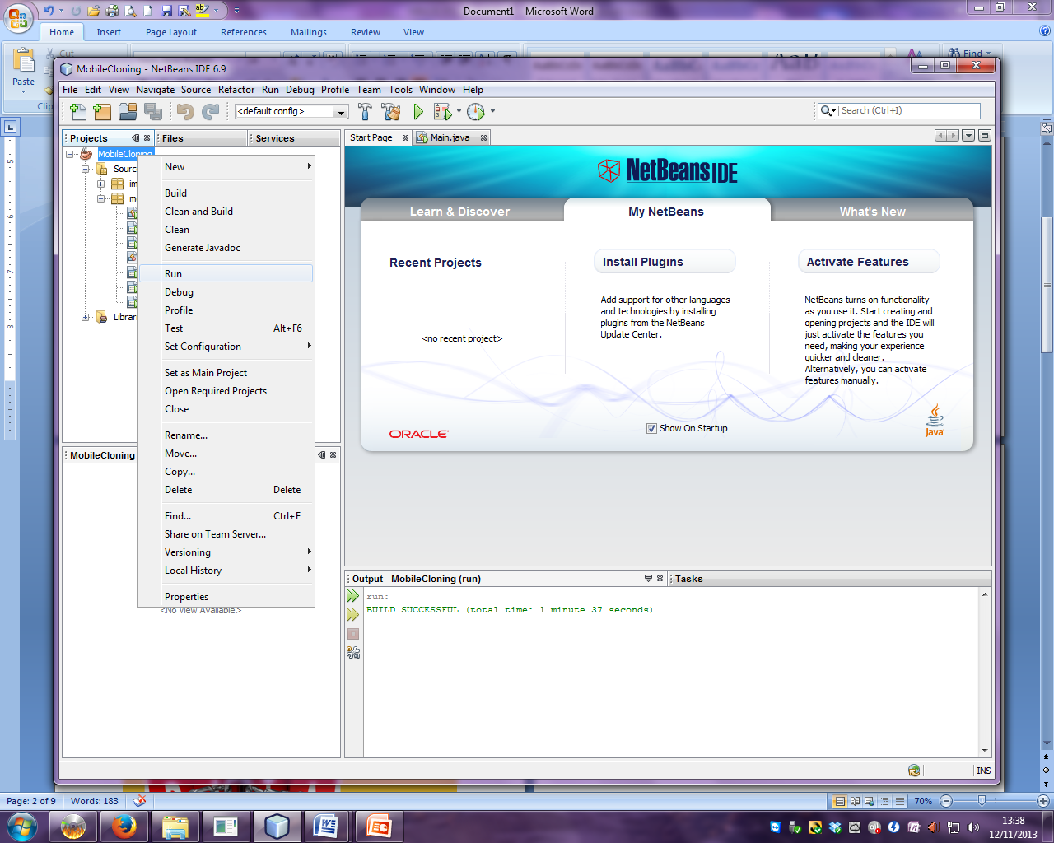

1. After running the project, the main application window opens…



1. Click on **“Continue”.**
2. A “Registration Module” opens asking the user for his/her registration details. First time users need to register themselves first.

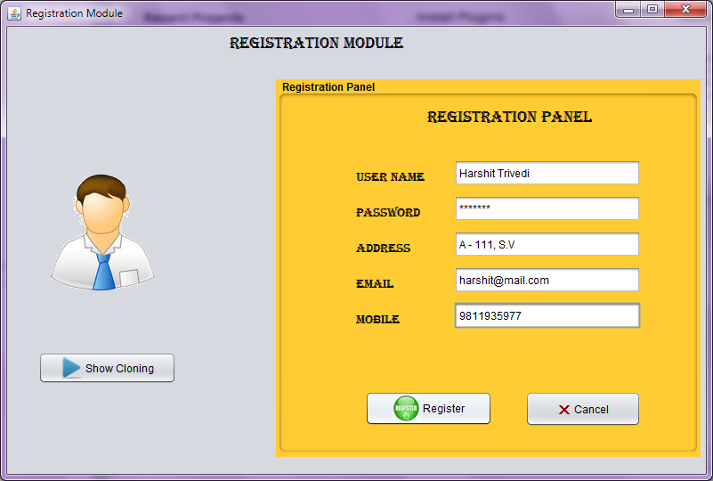

1. When you click on the button “**Show Cloning**” a window appears that contains data of all registered users.

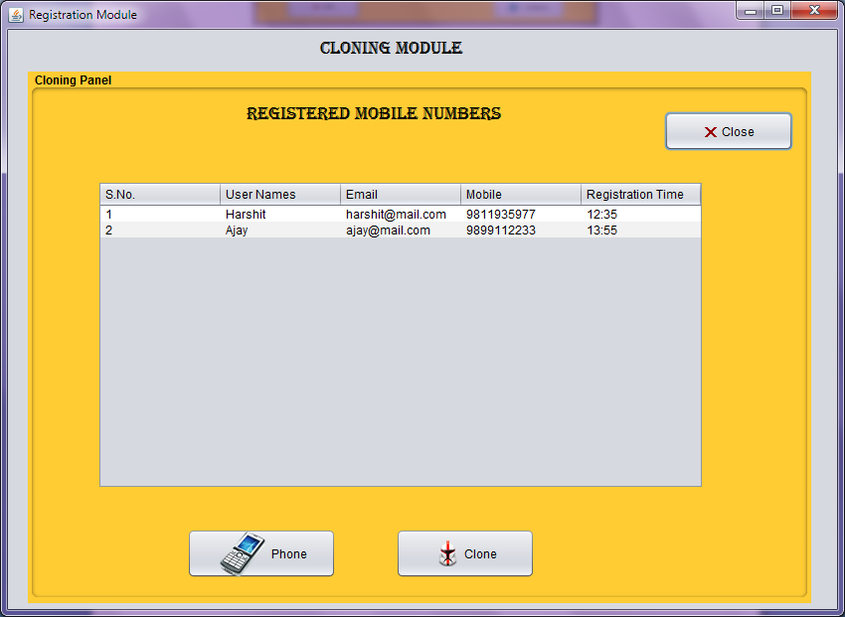

1. Here, we can select any contact to view its location and SIM details.

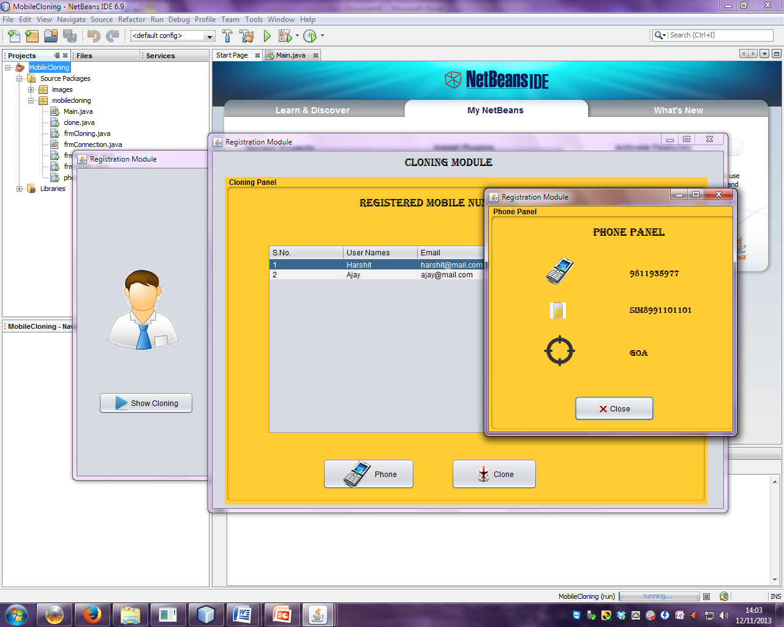

1. Now, click on the **“Clone”** button to detect the fake user, because with the same Contact and SIM No., different location is found which is not possible. Hence, it shows **CLONING**.

